**The Interaction between Groundwater and Surface water**

**The Concept, Instrumentation and Application to the Rideau Valley Watershed**

By Mezmure Haile-Meskale, Ph.D. P.Geo

Ontario Ministry of the Environments (MOE) Environmental Monitoring and Reporting Branch (EMRB)

ABSTRACT

This study describes the concept, instrumentation and application of groundwater/surface water interactions to the variable conditions within the Rideau valley watershed. In order to examine and evaluate the overall situation, ample data on water levels and seepage fluxes were collected during 1998 - 2001. The findings indicate the importance of climate change and other variables, such as hydraulic gradients and permeability that vary from one sub-watershed to the other. Within a certain year, the effects of the dry and wet periods are accentuated in some parts, whereas they are hardly felt in other parts. During the 1999, seepage fluxes had been minimal in many places. Where slope is not a major factor, the different permeability ranges across the overburden material have controlled the amount of seepage fluxes. The data also indicate that it is not only monthly but also the yearly climatic variations that affect the magnitude and direction of seepage fluxes.

RÉSUMÉ

Cette étude décrit le concept, l'instrumentation et l'application des interactions entre les eaux souterraines / de surface aux conditions variables dans le bassin versant de la vallée Rideau. Afin d'examiner et d'évaluer la situation globale, de nombreuses données sur les niveaux d'eau et les flux d'infiltration ont été recueillies au cours de 1998-2001. Les résultats indiquent l'importance du changement climatique et d'autres variables, telles que les gradients hydrauliques et la perméabilité qui varient d'une sous-ligne de partage à l'autre. Dans une certaine année, les effets des périodes sèches et humides sont accentués dans quelques endroits, tandis qu'ils sont à peine sentis dans d'autres. Pendant le 1999, l'infiltration jaillit avait été minimale dans beaucoup d'endroits. Là où la pente n'est pas un facteur important, les différentes gammes de perméabilité à travers le matériel de terrains de recouvrement ont commandé la quantité de flux d'infiltration. Les données indiquent également que c'est non seulement mensuel mais également les variations climatiques annuelles qui affectent l'importance et la direction des flux d'infiltration.

## INTRODUCTION

Groundwater and surface water are in constant interaction at various degrees depending on space and time. Whenever regional climatic variations occur, different parts of the land and water behave in different ways, depending on a number of integrated factors. The presence of an excessive amount of surface water during certain months of the year, and the abundant water from snow melt during the spring are the two climatic effects that can be easily observed in most parts of Canada.

In the South-eastern Ontario, where the soil gets over-saturated after snow melt, the unconfined ground water table intersects any low lying ground surface, whereas the confined aquifer below becomes pressurised. With the contrasting climatic factors between the wet and the dry season, and the different degree of response of aquifers to these variations, the vertical hydraulic gradients also vary in magnitude and direction. Consequently, surface water and groundwater bodies move in accordance with the differential pressure that exists at the interface (the bottom part of the surface water bodies).

This study describes, in particular, the overall characteristics of the sub watersheds of the Rideau Valley, based on the analysis and interpretation of the data that had been collected from water level and seepage flow measurements conducted mostly during 1998 – 2001 from twenty one (21) mini-piezometers and seven (7) seepage-meters were (Figure 1). The objective of this study was to understand the different factors, mainly climate, soil characteristics, land form, geology and land use, affecting the overall eco system of the Rideau Valley Watershed. The documentation of this study was finalized as part of the ongoing work towards an understanding the reasons for groundwater fluctuations of the Southern Ontario (work on progress).

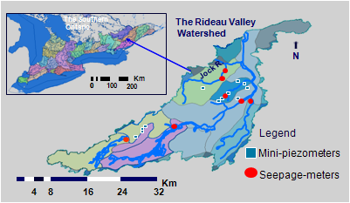

Figure 1: Location map of the studied area

1.1 The Concept

An interaction between the groundwater and surface water occurs at the points of interface between the surface water and groundwater (Figure 2). During the process of interaction, one of the two water bodies either gain or loss water. As shown on the figure, the movement of water is caused by the relative difference in pressure that exists at the interface; water must flow from a point of high pressure to a point of low pressure.

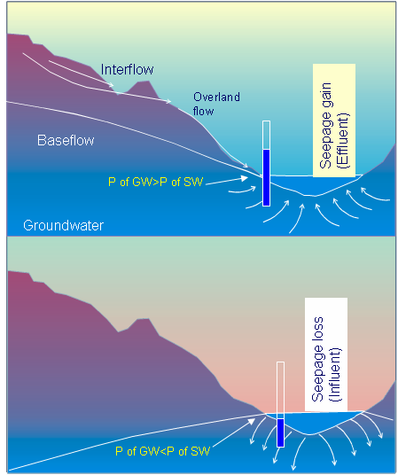

Figure 2: The three main routes of a water flow and positive and negative seepages

A water particle follows three main routes of travel before it reaches a stream channel:- An overland flow (or surface runoff) travels over ground surface to a channel; an interflow (or subsurface flow) infiltrates the soil surface and moves laterally through the upper soil layer until it enters a stream channel, drainage ditches, tile drain etc.; and groundwater flow (or baseflow, also called dry weather flow) percolates deep until it reaches a water table and eventually discharges into streams as groundwater flow (Linsley, et al. 1975). Other types of flows prevail in different environments, such as flows in karst terrain (Sophocleous M. 2002).

In general, flow components could be influenced by several factors, such as surface outcrops of bedrock along streams, extent of fracturing and jointing (bedding), relative thickness of soil over the bedrock, kind of surficial materials and their permeabilities, hydraulic gradients of the water table, hydro-geomorphologic condition, depth to the groundwater, climatic characteristics, urban development and vegetation, etc.. When positive gradients occur, surface water bodies are replenished from groundwater, and when negative gradients occur they are depleted due to seepage loses.

Where bedrocks are exposed, almost all rainfall may reach streams via surface runoff. However, local topographic variations, coupled with extent of fracturing and jointing may favour direct infiltration to the deep groundwater. Otherwise, the infiltrated rain water may be short circuited (interflow) before it reaches the groundwater table. Generally, interflow conditions are favoured where relatively thin sediment overlies the bedrock or an impermeable layer. Unless interflows are intercepted by tile drains, or topographic breaks, such as along ditches or stream banks, or along bedrock fractures, it would be more likely that streams receive a greater part of their flow through baseflow (seepage flux).

In order to understand the significance of low flow situations, discharge measurements of the Jock River, which is one of the most important tributaries of the Rideau River, was examined. The average stream flow data of this river, obtained from the Rideau Valley Conservation Authority (RVCA), was analysed. The significance of low baseflow conditions can be visualized from the four years (1995 to 1998) mean monthly flows (Figure 3).



Figure 3: Variations of the mean monthly flows of the Jock River at Moodie Drive

During the indicated four years, the maximum monthly average flows were between 20 and 50 cubic metres per second, and minimum monthly average flows were between 0.1 and 0.5 cubic metres per second. In most cases, minimum baseflows occurred during July and August, and sometimes extended up to October. The average low flows (below 0.5m3/sec) have occurred 22% (227 days) of the times during 1995 - 1998. This corresponds to 2.6 dry months out of one particular year. Extremely low baseflow (less than 0.1 m3 per second) have also occurred within these years.

Such exceptional low flow conditions have been of a great concern to the inhabitants of the Jock River Watershed. Low flow conditions constrict the implementation of major projects that use substantial amount of surface water. It compromises the protection of the aquatic habitat and/or other recreational uses.

Conventional discharge measurements from gauge stations depict only positive flows. Although the amount of positive or negative seepage rate between any two consecutive gauges could be calculated from the difference in stream flow measurements along a river, this is not a usual practice, due mostly financial reasons. Hence, such studies become critical in order to examine how, why, where and when high and low flows occur along different streams. This would in turn help to understand the overall sub-watershed characteristics, including climatic factors and land use.

Certain methods, such as increasing vegetation cover along river shores help to decrease quick runoff and to augment groundwater flow towards rivers, ultimately improving both groundwater and the surface water quantity and quality. This fact is well understood and actions are being taken throughout the Conservation Authorities managing their watersheds. However, in doing so, an understanding of the continuous processes that take place, at the surface water and groundwater interface, that augment or deplete baseflows, would be as important, in order to improve existing management practices, and to develop groundwater protection strategies that maintain safe drinking water supply sources.

# METHODOLOGY

In accordance with theoretical flows, and as illustrated in Figure 2, the differences in elevations between the shallow groundwater table and the adjacent surface water determine all possible types of interactions (effluent and influent conditions). In using this concept, field applications have been designed, and the following two measurements have been taken:

* Elevations of the groundwater table from mini-piezometers and the adjacent surface water levels.
* Seepage flow measurements from seepage-meters.

Shallow groundwater conditions could be monitored from mini-piezometers or other piezometers. Seepage fluxes could be measured using seepage-meters that can be constructed in various ways depending upon the local situations. Carr M. R. and Winter T. C. (not dated) provide a bibliography of devices developed for direct measurement of seepages. The initial (1998) methodology was adopted from M. Robin (University of Ottawa). However, this study focused on a general understanding of the different scenarios that existed within the different parts of the Rideau Valley Watershed. Hence, the construction of the seepage meters was modified in order to acquire weekly variation, as opposed to an hourly or daily variation of other similar studies.

The mini-piezometers utilized in this study are from rigid polyethylene tubes (about 12 mm in diameter) attached to a screen (12 to 14 cm in length). These mini-piezometers were installed besides each seepage-meter, and also at other places where there are no seepage-meters (Figure 4). The method of installing these mini-piezometers is as follows:-

A hole is created by pounding down a hollow metal (about 20 mm in diameter) with a bolt loosely attached at the bottom end. Once the desired depth (about 50 cm or so) is attained, the polyethylene tube is pushed down while simultaneously pushing up the hollow metal tube, leaving the bolt behind.

A typical seepage-meter can be constructed by cutting about 22 cm end section of a metal container, about 51 cm in diameter. In this study, various types of seepage-meters have been designed and tried for the different environmental conditions that exist within the Rideau Valley watershed. The most widely used type (Figure 4) consists of an open bottomed drum (1), which was made to vary between 20 and 50 cm depending on the absence or presence of loose sediments under river bottoms or wetlands. Two hooks (2) have been welded at the opposite ends of the drum to facilitate the lifting off of the drum from sticky clayey type of sediments. Two ½ inches in diameter short PVC tubes (3) have been inserted through two holes drilled on the top and on the side of the drum. Transparent and flexible polyethylene tubes (4) are inserted through the respective PVC tubes (the hole in the inside part of the drum can be covered with a geo-synthetic filter in order to avoid build up of silt in the tube). The tubes were then directed towards the inlet into the plastic bag (5), and the polyethylene tubes and the bag are firmly tied together by a string (6). The plastic bag is inserted into a perforated protective metal box (7). This box should be heavy enough not to float, and it should be perforated so that the plastic bag is subjected only to hydrostatic pressure, while protecting the bag from aquatic habitats. An outlet (8) is made on the other end of the bag, which can then be easily closed and opened, using a stopper, each time measurements takes place.

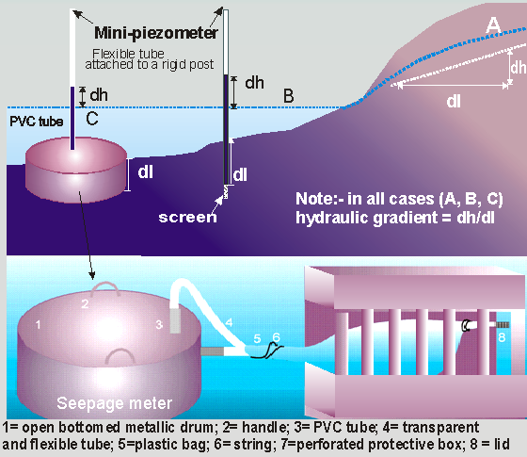

Figure 4: An assemblage of a seepage-meter and two types of mini-piezometers

The metallic drum is slowly pushed down until the polyethylene tube touches the sediment. Initially, one of the polyethylene tubes (4) is kept above the water surface, in order to drive out any gas that may be trapped inside the sediment. This tube can also be used as a piezometer (see upper part of figure 4), and it is preferred to do that especially in marshy areas, where emission of gas is expected. Initially, all air in both tubes must be sucked out using a rubber bulb, before inserting polyethylene tubes (4) into the plastic bag, which should also be air free. After a while, seepage water will enter the bag, and measurements can take place any time afterwards by pulling the plastic bag from its container and pouring the water into a graduated cylinder. This method can be applied where it is known that positive seepage flux occurs most of the times, or when only the cumulative effect over a long term (a week or two) is preferred to be known. Otherwise, a known amount of water must be kept in the plastic bag above the seepage-meter and below the water level, to measure the difference between the inward (positive flux) and outward (negative flux).

# Interpretations of the Field Results

The initial installation information and any related field observations, mostly obtained in 1999, are presented (Table 1). Collection of data had continued up to the summer of 2001. The surface water levels were referenced from a fixed mark (40 to 50 cm) on a wooden stake pushed into the sediment, close to the mini-piezometers. The places where seepage-meters had been installed are indicated on bold and pink numbers at the left side of Table 1.

Table 1: Data obtained during the initial installation of the mini-piezometers



The interpretation of the data has revealed different scenarios for different localities. A summary of the results for the different sub-watersheds is provided (Table 2). This table indicates the number of times positive or negative gradients have been encountered at the measuring points. The ratio between the negative and positive hydraulic gradients denotes if the measuring spot is mostly a recharge or discharge area. Also from the relative values of the ratios obtained, it can be speculated that certain areas would in particular be characterised by negative or positive gradients, which may imply losing or gaining water, respectively.

The seepage-meters used at most of the have been particularly suited for a positive seepage flux; the seepage flows have been measured usually once every week. Since negative seepage may have existed within this period, the amount of seepage water collected in this manner would only represent the average flow within the measured time interval. In most cases, only positive gradients were noted, although frequent negative gradients have been encountered in certain spots. In those places a known volume of water had been left in the plastic bag and kept on top of the seepage-meter to measure the difference. The seepage fluxes (millilitres per square metre per second) have been calculated by dividing the amount of water entering the bag by the circular area of the metallic drum (0.255 m2) divided by the time elapsed (v = V/t/ m2ml/sec/m2). The two measured parameters (gradient and seepage flows) could reflect different scenarios for the different parts of the watersheds, which could then be used to identify the spatial and temporal variations of the interactions between the surface water and groundwater bodies within each sub-watershed.

Table 2: Average vertical gradients and the probability of recharge/discharge conditions (1999 to 2001)



The overall data showed various highs and lows of both groundwater and surface water. During the wet period most part of the baseflow is attributed due to increase in seepage from interflows discharged at discrete places along streams. However, simultaneous increase in surface water and groundwater level does not necessarily relate to increase in seepage flux; it is the relative increase in the difference between the two that corresponds to positive or negative seepage fluxes.

The data gathered showed direct relationship between the hydraulic gradients and seepage flows, for a specific permeability at a fixed location. But the correlation coefficients were not very strong in all cases (around 60%). This is because the measured hydraulic gradients represent the day of measurement, whereas the seepage rates represent the effect of all (infinite) hydraulic gradients between the one week intervals when measurements have been taken. If there had been a stronger correlation, it would then mean that the discrete hydraulic gradients measured during the specific days would be representative of the average of the week.

Ideally, seepage flow measurement, which is the amount of flow within a specific time, should correspond to infinite head measurements within that time. The period when precipitation occurs could be considered as discrete event and, depending on the response of aquifers to infiltration, increase or decrease in head (or gradient) could also be considered as discrete. Therefore, seepage flux and hydraulic gradient measurements taken on short intervals (hourly or daily) bases will provide better results. One of the advantages of weekly measurements however, is that it is less labour intensive and can be performed more economically for several months within various watersheds (sub-watersheds). The collected samples may also be used for chemical analysis.

3.1 The Integrated Factors

Normally, aquifer characteristics are determined from aquifer performance tests, such as pumping or recovery tests. Such tests have not been achieved; instead, permeabilities of the soil types have been estimated by defining their primary and secondary characteristics at each site, and then assigning the corresponding approximate range of values provided in text books, such as Freeze, A., and Cherry, J., (1979). The data compiled in this manner (Table 3) has been verified by comparing the 1:50,000 surficial geology maps and the corresponding permeability layers using an ArcGIS platform. As shown on Table 3, the soil type characteristics and the corresponding permeability ranges vary significantly from one site to another.

Table 3: Summary of the Integrated Factors Affecting Seepage Rates



Permeability can also be back calculated from the observed seepage fluxes. In this case , however, it is desired to examine the factors affecting the measured seepage rates, and subsequently estimate the seepage rates for those areas where seepage-meters have not been installed. Hence, the average hydraulic gradients and the corresponding permeabilities from Table 3 were integrated, and a relationship envisaged with the measured seepage rates (Figure 5, upper part).

As shown on figure 5, a very good correlation (98%) was obtained between the integrated permeability times gradient and the measured seepage rates. In using the equation from the upper part of figure 5 (y = 0.0003x - 3E-07), the permeability values have been adjusted for all other sites, where seepage-meters have not been installed. Also obtaining porosity values from Table 3, the average linear groundwater velocity or the interstitial seepage velocity, which is defined as the permeability times gradient divided by the corresponding porosity, was calculated. The adjusted permeabilities have then been used to calculate the seepage velocities for all the sites, in using the measured hydraulic gradients and the estimated porosities.

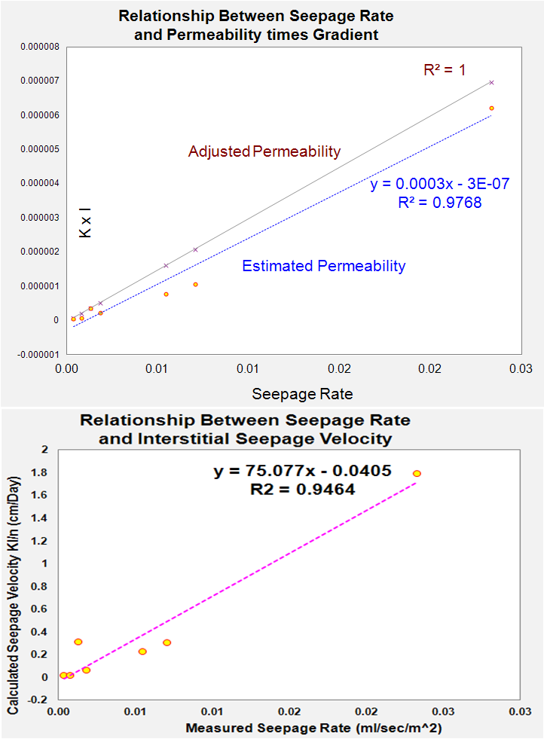

(ml/sec/m^2)

Figure 5: Relationship between the measured seepage rates, permeability & gradient (upper figure) and the measured seepage rates & the interstitial seepage (lower figure)

The measured seepage rates were plotted against the interstitial seepage velocity (average linear groundwater velocity). Again, a very good correlation (about 95%) was obtained (Figure 5, lower part).

The data compiled in this manner has been used to assess the situation per sub watershed where measurements have been taken. The integrated results were then presented on various maps. For each study site, a surficial geology map, a permeability map and a landsat image have been displayed. The locations of the sites are indicated on each map from which the respective geology and permeability can be deduced. Land use and land forms can be deduced from the landsat images. Over each landsat image, a summary of the following results (in the form of pie diagrams and charts) have been presented:

* The relative magnitude of the hydraulic gradients, represented by the size of the circles, direction of the hydraulic gradient, represented by the colours (red for negative), and the number of events, represented by the portion of the circles (upper part of figure 6).
* The relative magnitude of seepage rates, as can be compared from KI (lower part of figure 6).

Based on the diagrams and charts over the maps, the manner in which the groundwater and surface water interact has been discussed for each site. One such example is presented (Figure 6). The lower part of the map on the figure reflects the overall situation in the sub-watersheds of the Rideau valley where measurements took place. On this map, the bar charts indicate the relationship of gradient, which is the main driving force for seepage flow, and the composite effect of permeability and gradient, which corresponds to the amount of seepage flux. By comparing the relative magnitude of the blue and red of the bar charts the relative amount of gradient and seepage flux can be compared spatially.



Figure 6: The integrated aspects of geology, permeability and topography (or hydraulic gradients) reflecting seepage directions and flows

Thus, having prepared similar maps for all the sub watersheds of the Rideau Valley, certain unique characteristics were observed. Some of the salient features are discussed below:-

As shown on the upper part of the figure 6, the distinct role that geology and permeability plays within the Jock River and Kings Creek (Area A) can be observed. The stream beds along the Kings Creek are composed of rock fragments derived from the adjacent Palaeozoic rocks. Some gravel and sand can also be expected due to the Till unit at the upper course. This area has a rugged topography and is moderately vegetated. It is characterised by its high hydraulic gradient and high seepage flux. On the contrary, the lower part of the Jock River is characterised by its flat topography. It is predominated by silt and clay; fertilizers are applied on the cultivated parts. The two locations within this part of the river basin showed relatively low hydraulic gradients and very low seepage rates. Both positive and negative gradients have been recorded. Towards the middle part of this watershed (where the bedrock starts to be covered with the overburden), both local recharge and discharge situations exist. Further to the east (towards the lower parts of the watershed, where the clay unit is thickest), mostly local discharge situations prevail. The very low seepage rates at the two locations along the Jock River signify the very low permeability of the clay unit coupled with the corresponding very low hydraulic gradients.

In area B, the upper, middle and lower parts of the Mud Creek exhibit variable situations, which largely depended upon local topography. The Upper Mud Creek is predominantly composed of silt and clay. Although the permeability is low, the seepage velocity has been relatively moderate due to the relatively high to medium measured gradients. The measuring site at the Middle Mud creek is located only few metres to the east of a highly permeable sand and gravel deposits belonging to the northwest to south east trending esker. At the measuring site, the creek dissects a relatively flat ground surface, where the maximum high groundwater table is close to the ground surface. This site is characterised by its high negative gradient. The measuring site at the Lower Mud creek is located within the part of the stream dissecting a gully. No negative gradients were detected at the lower Mud Creek.

In area C, the overburden material of the Upper Cranberry Creek at Malacoff is highly permeable; medium grained and well sorted sand. The river bed is situated on top of a Post Champlain deposit (Beach sand). The Rideau River, just south of Malacoff Drive and the Lower parts of the Kemptville Creek also have similar geology, and the permeability in all these areas is considered to be high**.** The relatively very high seepage velocities at the Upper Cranberry Creek, regardless of the low gradients can be attributed to the influence of the high permeability of the sand. Although considerable surface water flow (50 or more Litres/sec) can be observed from the Upper Cranberry Creek at Malacoff Drive during the wet season, this Creek quickly loses its water during the dry season. Seepage measurements were taken from the Rideau River at Malacoff Drive, where a very variable seepage flux (ranging from about 0.006 mm/sec to about 0.07 mm/sec) has been detected. The variable rate could be attributed due to the tidal effects of the river, which fluctuates at +/- 2 cm on average. This location is particularly characterised by its low gradient and high seepage fluxes. Although considerable loss could be expected during the tidal lows, the overall seepage rate is relatively high. A seepage-meter has also been installed towards the lower end of the Kemptville Creek. The medium to high permeability, regardless of the low gradient, accounts for the relatively medium to high seepage rates. The Kemptville Creek at this location suffers from a back water effect from to the Rideau River. This back water is affecting both the groundwater and the surface water levels. The river beds of the lower parts of the Cranberry and Stevens Creeks are predominantly composed of silt and clay, overlain by organic deposits. The permeabilities of the overburden at these locations are considered to be low**.** Although no seepage measurements have been taken at these locations, the extrapolated results indicate low seepage velocity signifying the composite effects of the low permeability and moderate to low hydraulic gradients. It can be deduced, from the mini-piezometer measurements at these locations, that the surface and groundwater levels are affected by the influence of the back water from the Rideau River.

In area D, four sites along the Roger Stevens Drive represent a wetland area extending more towards the north of the site. The wetland lies over Palaeozoic bedrock whose permeability is considered to be variable. The overburden material consists of some gravel from the Till Unit, overlain by organic sediments composed of silt and dead aquatic habitats. The overall permeability of the material beneath this wetland can be considered as medium. The groundwater levels have always been positive (above the surface water level) towards the centre of this wetland, although some negative values have been observed towards the east and west of the wetland. During the dry periods, when the stream water levels are low, water level in the wetlands also tend to lower, but the groundwater level, as measured from the seepage-meters at the middle part of the Richmond Fen, remained almost constant. The fact that this wetland is permanent towards the center suggests that it is being fed by an upward groundwater flow from the permeable gravel deposit below. This is supported by the constant seepage flux (at about 0.006 mm/sec) throughout the seasons, as measured from its central part. At the current situation, the integrity of the Richmond Fen and its groundwater/surface water situation is at a favourable stage towards its central part. However, any reduction in its vegetative cover could result in a loss of available surface water that could possibly result in ephemeral situation as the adjacent wetlands. It can be assumed that any significant amount of groundwater in this area is attributed to the bedrock aquifer below. Therefore, heavy extraction of groundwater from the bedrock aquifer could also contribute in reducing the size of the wetland.

In area E, the surface water bodies occupying the troughs within the Upper Tay River watershed emanate from the Precambrian rocks occupying the highly vegetated ridges. The Precambrian rocks have very low permeability and the groundwater table within the ridges is expected to be high. The overburden material along the troughs (moderately cultivated) consists mostly of rock fragments derived from the adjacent ridges and the underlying bedrock. The material type within the trough reflects mixture of these fragments from the Precambrian rocks and overburden from the Till Unit. Accordingly, variable permeabilities are expected. The Tay River north of Christie Lake lies in a relatively open landform, where the geology and permeability differs from the previous. This part of the watershed has a relatively thin overburden consisting of Till. The bedrock is exposed in some places along the river bottoms of the Tay River. In general, the permeability of the overburden in the Lower Tay River can be considered as low to medium. The groundwater levels have always been positive (above the surface water level), indicating that the Tay River system is being replenished by the adjacent groundwater all the time, with the exception of flooding or damming events, or ponds created by beavers. The measured seepage rates at the Christie Lake and Port Elmsley and the extrapolated seepage velocities along the Tay River show that the stream beds along the Tay River have constant but low seepage velocities, signifying the corresponding medium to low hydraulic gradients and low permeabilities.

# CONCLUSION

The cost effective methods of groundwater level measurements from mini-piezometers and seepage rates from seepage meters can be applied wherever it is desired to understand the interactions between surface water and groundwater. The piezometers and seepage meters can be constructed in various ways depending on local conditions. In addition to what has been discussed herein, water samples can be collected easily from seepage metres, from which the effect of land use on surface and near surface groundwater quality can be understood.

The principal point that can be observed from this study is that groundwater and surface water interact in various ways depending on time and space. The resulting information can then be used to establish sub-watershed characteristics in a certain manner. For example, from the relative differences between the sub-watersheds in hydraulic gradients and seepage fluxes alone, the differences in the integrated aspects of the geologic, topographic, permeability, vegetation cover can be deduced. The overall information can provide some clue as to the significance of flooding and damming. In areas where response to climate change becomes significant, the connectivity of the deep ground water with the near surface groundwater and surface water may also be significant. Hence, such a study could provide some clue on groundwater under direct influence of surface water (GUDI. Subsequently, the information that can be gathered from such a study could help in explaining reasons for the variability in the shallow, intermediate or deep groundwater levels as well as quality.

In general, knowledge of how groundwater and surface waters interact along streams becomes important to understanding both the surface water and groundwater conditions at all levels. Therefore, besides the conventional gauge stations, a proper management of watersheds could benefit from additional data supporting the temporal and spatial variations of seepage fluxes that occur all along stream courses.

This study has identified areas where differentiating local and regional recharge areas become important. For a given stream, effluent conditions (gaining water) prevail almost all the time for locations that exhibit relatively high hydraulic gradients, and influent conditions (losing water) may prevail most of the times for locations that exhibit low hydraulic gradients. On a local scale, each sub- watershed may have its own recharge/discharge zones. However, vertical gradients (positive or negative) may occur at any place, as long as differential response characteristics exist across the different thickness of aquifers and aquitards. In certain instances, some streams can be influenced by an upward movement of groundwater flow, where a confining layer exists below a stream bed. Although this situation has not been encountered within the Rideau River Watershed, it is believed that it occurs in the eastern Watersheds (South Nation and Raisin) where streams traverse the Till Unit (the Till Unit exhibits various layers with different aquifer properties).

The application of such a simple field method discussed in this study has revealed following outstanding characteristics of the Rideau Valley Watershed:-

In general, the topographically high areas (ridges within the Precambrian basement complex of the Upper Rideau Valley Watershed) are recharge areas. In these areas, a part of the groundwater is always being discharged into streams and lakes along valley bottoms (troughs). But when drought conditions prevail, the hydraulic gradients within the ridges could be so minimal that no groundwater could make it to the surface.

The topographically high areas of the Palaeozoic rocks (such as the upper reaches of the Jock River watershed) are local recharge areas and groundwater is being discharged into stream beds where they happen to cut the high groundwater level.

Both groundwater recharge and discharge conditions are prevalent in the area where the Palaeozoic rocks are exposed, between Smiths Falls and the Village of Richmond. In this area, ephemeral wetlands are prominent, suggesting that the shallow bedrock aquifer gets fully saturated because of excessive recharge during the wet periods. In this area, the lowering of the shallow bedrock groundwater could compromise the integrity of the wetlands, thus facilitating contamination due to the interconnectivity with the surface water.

Most parts of the Middle Rideau Valley can be considered as an area where both groundwater recharge and discharge conditions takes place. Where a stream bed is traversing a permeable formation, a relatively rapid infiltration (groundwater recharge) takes place at that location (for example the middle Mud Creek). The Lower Rideau valley can in general be considered as a discharge area. This situation facilitates upward seepage. Unless severe drought conditions prevail no seepage loses can be expected in most parts of the Lower Rideau.

Acknowledgements

The writer would like to acknowledge the Ministry of the Environment (MOE), Environmental Monitoring and Reporting Branch (EMRB), under the leadership of Ian Smith, Director and Lisa Trevisan, Manager for allowing the publication of this study.

The collection, integration, compilation and interpretation of the data have been possible through the leadership of Dell Hallett, P. Eng., General Manager and Mr. Bruce A. Reid P.Eng., Director, Watershed Science and Engineering Services of the Rideau Valley Conservation Authority (RVCA).

The writer would also acknowledge the contribution of a number of individuals to the paper. The methodology was initiallyintroduced to the Rideau Valley by Dr. Michel Robin (University of Ottawa). The screens for all the mini-piezometers were constructed by Tessa Di Iorio (South Nation River Conservation). The seepage meters have been constructed with the assistance of the RVCA's work shop. The writer would also appreciate Kathy Facey and others who assisted in the collection of field data.

REFERENCES

Anderson P. Marry and William W. Woessner, 1991:

*Applied Ground water modelling, Simulation of Flow and Advective Transport*; Academic Press, SanDiego, New York, Boston, London, Sydney, Tokyo, Toronto.

Arnold,J.G. and P.M. Allen. 1999: *Validation of Automated Methods for Estimating Baseflow and Groundwater Recharge from Stream Flow Records*; Journal of American Water Resources Association v. 35, no. 2, p. 411-424.

Baxter,C.,Hauer, F.R., and W.W. Woessener. 2003: *Measuring groundwater-stream water exchange: New techniques for installing minipiezometers and estimating hydraulic conductivity*; Transactions of the American Fisheries Society 132: 493-502.

Carr M. R. and Winter T. C. (not dated): *An Annotated Bibliography of Devices, for direct measurement of seepage*; united states, department of interior, geological survey developed Open-File Report 80-344, Denver, Colorado.

Chow, V.T.Maidment, D.R., and Mays, L.W., 1988: *Applied Hydrology;* McGraw-Hill, New York, NY.

Freeze, A. and Cherry, J., 1979: *Groundwater,* Prentice-Hall, Inc.*,* Englewood Cliffs, NJ.

Lee, D. R. 1977: *A device for measuring seepage flux in lakes and estuaries;*  *Limnology and Oceanography* 22(1): 140-147.

Linsley, R.K., Kohler, M.A., and Paulhus, J.L.H., 1975: *Hydrology for Engineers, 2nd edition;* McGraw-Hill Series in Water Resources and Environmental Engineering, McGraw–Hill, Inc., NY.

Porter Sandra, 1996: *Groundwater/Surface water Interaction in the Raisin River Watershed, Near Cornwall, Ontario;* Masters Thesis, University of Ottawa.

Rosenberry, D. O. 2008: *A seepage meter designed for use in flowing water;* Journal of Hydrology 359: 118-130.

Sophocleous M. 2002: *Interactions between groundwater and surface water: the state of the science;* Hydrogeology Journal (2002) 10:52–67.

Winter, T.C., LaBaugh, J.W., and D.O. Rosenberry. 1988: *The design and use of a hydraulic potentiomanometer for direct measurement of differences in hydraulic head between groundwater and surface water;* Limnological Oceanography 33(5): 1209-1214.